

Mrs Lekha Mahesh Kulkarni.

Educational qualifications: M.Comm. , B.Ed ( English- Geography) from Adarsha Comprehensive College of Education and Research,  Diploma in Child and Education Psychology from Jnana Prabodhini

She has 8 years of experience in the field of Education.

Becoming a teacher and now living it is like a dream come true for her.  Along with it, she thoroughly enjoys music and going for treks.

If asked what her 2nd career option would be, if not an Educator then she would say a radio jockey owing to which she also does podcasting once in a while using mobile phone.

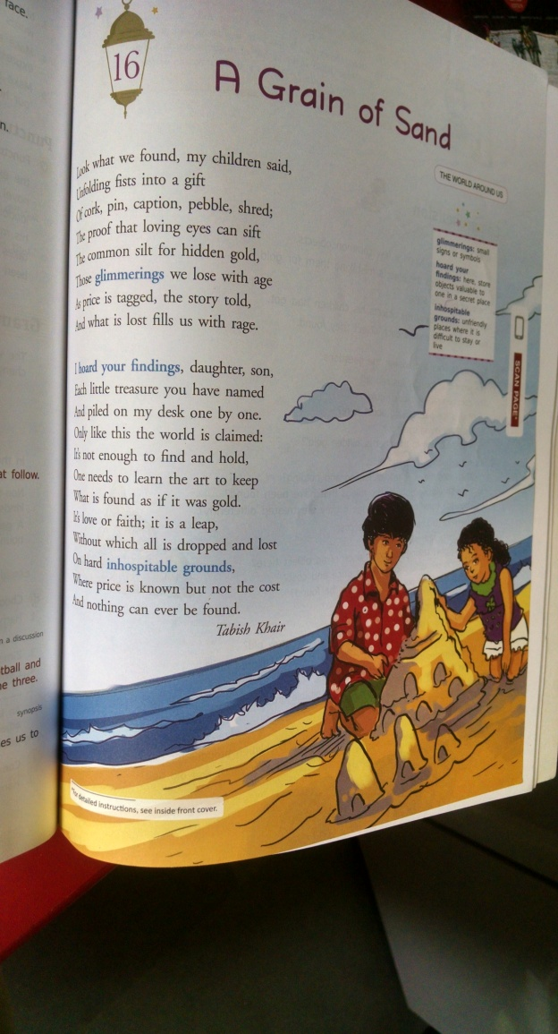

**5 E Lesson Plan**

1. *General Information*
2. Name of the School: Dr. KalmadiShamaraoHighschool, Ganeshnagar
3. Name of the Teacher: Mrs. Lekha Mahesh Kulkarni
4. Date: 02.10.2018
5. Subject: English
6. Grade: VIII
7. Topic: A Grain of Sand
8. Unit: Poetry
9. State Curriculum Standards: C.B.S.E
10. *Lesson / Unit Planning:*
11. **Short Description of the Concept:**

The Poet’s children came up to him to show him gifts that they found in sand like corks, pins, a pretty pebble and a bit of something. The poet thought they were precious items comparing them to gold.

The poet says he has and will treasure every single item of it and claims to own the world not just simply by finding it and holding it but by hoarding it and naming every part of it.

This imagination the poet says, can only happen when you love the person who gave you the gifts or if you trust them completely. The poet further introspects and states that we are in a situation where we know the price of every single object in our lives but have no idea of what they cost to be in our life.

1. **Statement of Learning Objectives:**

The student will be able to –

1. Read and relate to the poem by Tabish Khair
2. Express and draw inferences from the poem
3. Construct the rhyme scheme and recite the poem with expressions
4. Debate over ‘cost of living’v/s ‘value of things’
5. Select their way of living from the debated points
6. Construct and write a poem using the rhyme scheme learned.
7. **Differentiation strategies to meet diverse learner needs:**

Ask the students –

1. If they have collected objects from their early childhood and if they still have them?
2. Where they have kept them?
3. Who has taken care of them?
4. Why people collect things and take care of them?
5. For a talkative and orally expressive student:

Encourage to talk about the topic so that they realize that the sentimental value attached to the objects is greater than the cost of the objects.

1. For the students who are able to express through written work:

Recall about such collected objects and write about the memories attached to them in a descriptive essay.

* Note : Point (a) and (b) is applicable to average and below average students whereas the following point (c) is applicable to above average students.

1. 5. **Adaptations / Accommodations’ for Exceptional Students:**

Pose the following question-

How would be the early childhood memories of an orphaned child? Elaborate.

1. **Common Learners Misconceptions:**

Students generally tend to value expensive and branded things, over money wise – cheap but the ones rendered with love.

This is the main concept which needs to be taught through this poem.

1. **Precautions / Safety Measures:**

Tr. needs to be extra careful that no such question is posed to a student who is facing some personal tragedy / drawback.

e.g. there could be a student who has lost one or both his / her parent; so avoid posing point 5 (c) question to such a student.

* Note: For this make sure you as a teacher is aware of each and every students basic personal background with the help of the school counselor.

1. *Instructional Process*
2. **Engage**

**Using Immersive reader software.**

Read the poem and ask the following questions-

1. What do the children have in their closed fists?
2. Where do the children keep them?
3. What does the poet do with those things?
4. **Explore**

Note : Before starting with the lesson ask each student to bring any one of their

favourite childhood photograph.

Ask students to share their fond memories / experiences by displaying their photograph

in front of the class.

1. **Explain**

Tr. interprets the poem stanza by stanza and explains the different expressions used by the poet to convey the theme of the poem.

PPT showcasing the growing up stages and changes and the things that we miss upon or forget doing in the bargain.

1. **Elaborate**

In reference to the context of the poem explained, Tr. shows the video – ‘This Jar Represents to your Life’ and elaborates how it is important to value and prioritize relations and create memories in life.

Tr. elaborates the following **figures of speech** by giving examples from the poem and elaborating them by giving more out of the text examples.

Simile- Comparison is made between two objects of different kinds which have at least one point in common. (Use of – like, as or so.) e.g. Sam runs as fast as a Cheetah.

Metaphor- An indirect comparison is made between two unlike objects which are alike in only one aspect hence words like, as and so are not used. E.g. The camel is the ship of the desert.

Repetition- Here musical effect is created when the words are repeated. E.g. much, much later.

Alliteration- When similar sound or repetition of similar letters are used to produce poetic effect. E.g. And hears the person pray and preach.

Personification- Inanimate objects and abstract ideas are given human qualities. They are spoken of having life and intelligence. E.g. Death lays its icy hands on king.

Antithesis- A striking opposition on contract of words or sentiments or feelings is made in same statement to emphasize. E.g. Man proposes, God disposes.

1. **Evaluate**
2. Tell the students to read the poem and underline end-rhymes. Once this is done, the **rhyme scheme** can be identified.

So for Stanza I the end rhyme words are – said, gift, shred, sift, gold, age, told, rage.

That means the rhyme scheme is – A,B,A,B,C,D,C,D

Students will now find the rhyme scheme for Stanza II

1. Find the meaning of following phrases- i. eyes can sift; means eyes can examine something very carefully in order to decide what is important or useful.

ii. Common silt for hidden gold; means valuable treasures even in most common situations or surroundings.

iii. Learn the art means the skill or technique.

1. Identify the verses from the poem for the following Figures of Speech
2. Metaphor – Common silt for hidden gold
3. Repetition – Piled on my desk one by one
4. Antithesis – And what is lost fills us with rage
5. Write your own poem elaborating on any one fond childhood memory of yours using the same rhyme scheme as ‘A Grain of Sand’.
6. *References / Resources*

<https://youtu.be/_p0UsghdF6A> (video)

**Note –** Technology inclusion is shown in RED colour.

Teacher reference notes are in BLUE colour.

**Rubric** for the above point ‘d’ is as follows:-

|  |  |  |  |  |  |
| --- | --- | --- | --- | --- | --- |
| Criteria | 1 | 2 | 3 | 4 | Your Score |
| Verse/Word Spacing | The poem looks like prose; no clear sense of the significance of spacing | The text is formatted in poem ‘form’, but the spacing does not seem purposeful | Some spacing seems purposeful and creative, other spacing seems accidental or random | The poem’s line and word spacing is creative, purposeful, and enhances the meaning of the poem | 1  2  3  4 |
| Figures of Speech | There are no figures of speech included, thus indicating lack of understanding about it | Some verses appear poetic but are not fully developed | Easy figures of speech are present like alliteration, repetition etc. | Complete understanding and application of poetic and Figures of speech is evident | 1  2  3  4 |
| Rhythm/ Rhyme | There is no recognizable rhythm to the poem | There appears to be rhythm to the poem, but it is somewhat inconsistent | The rhythm of the poem is easily recognized, but does not make sense with the content | The rhythm of the poem is easily recognizes and clearly consistent with the content | 1  2  3  4 |
| Tone | The tone or the mood of the poem is unclear | The tone or mood of the poem is somewhat clear, but inconsistent | The tone or mood of the poem is clear, but inconsistent | The tone or mood of the poem is completely clear and consistent with the context of the poem | 1  2  3  4 |

Resources:

